

Configuring an Application Using the Datamaxx Web Services Software

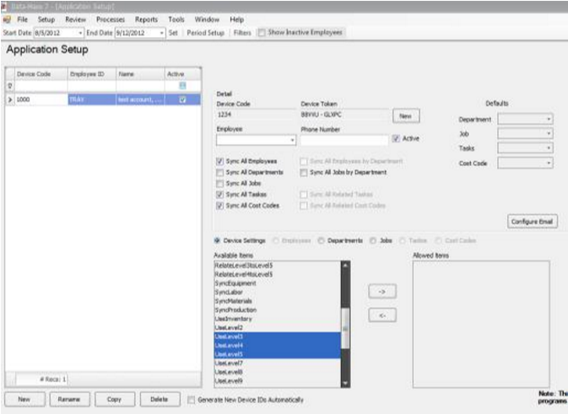

1.

Open Datamaxx V7 and Browse to Setup > Application Setup

2.

Click the New Button in the Bottom Left



1. If you are using any web application choose detailed at the top
2. At the button of the screen below available items choose the application that you want to configure

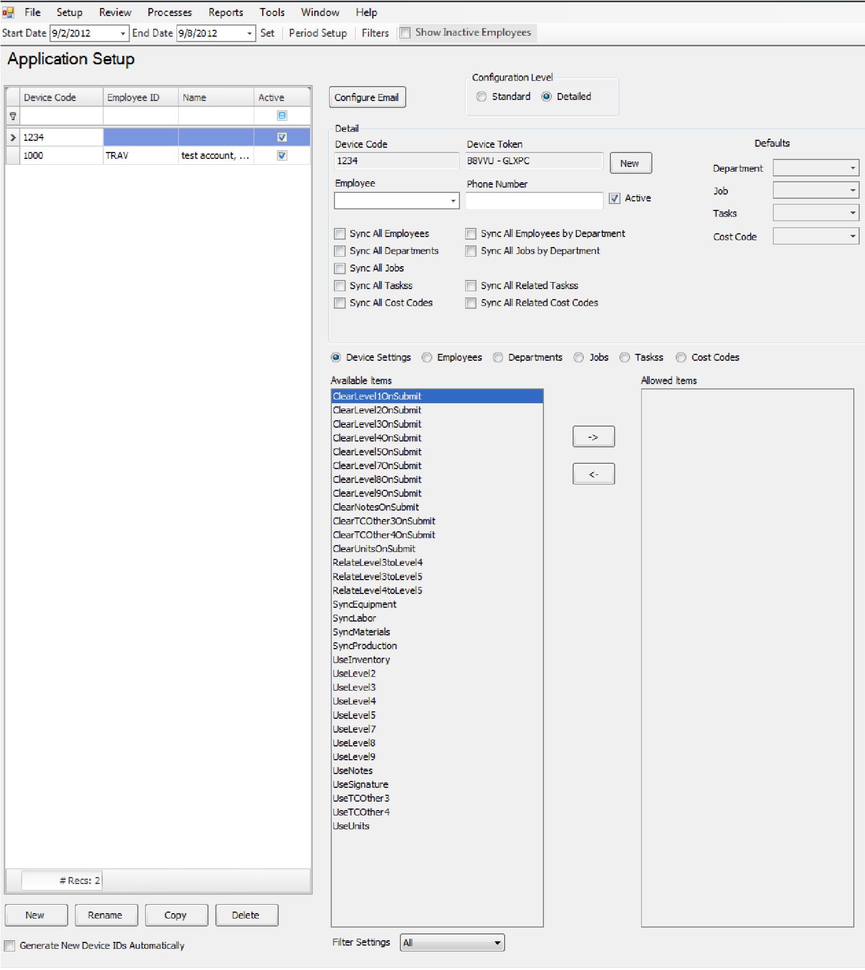

5.

Start with any device Naming Schema (i.e. 1000, then 1001, 1002

etc…)

a.

Choose the Employee Assigned to the Device

b.

Choose what levels you want to track

Click the

Right

-

>

to

add them to that device,

Left <

-

to take them off

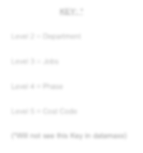

**KEY:**

**\***

Level 2

=

Department

Level 3

=

Jobs

Level 4

=

Phase

Level 5

=

Cost Code

**(**

**\*W**

**ill not see this Key in datamaxx)**

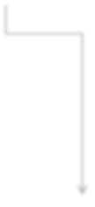

1. Previous setups can be copied and renamed for a speedier Setup by using the Copy Button at the bottom left of the screen

1. If you are using an application that user security on it you will have to create that user a Log in in Datamaxx V7
   1. From the datamaxx menu Choose Tools > Security > Users
   2. Add a user name in the line below Name in the Users Column on the Left
   3. Click add all forms disabled if they will not be logging into Datamaxx V7
   4. Set a password

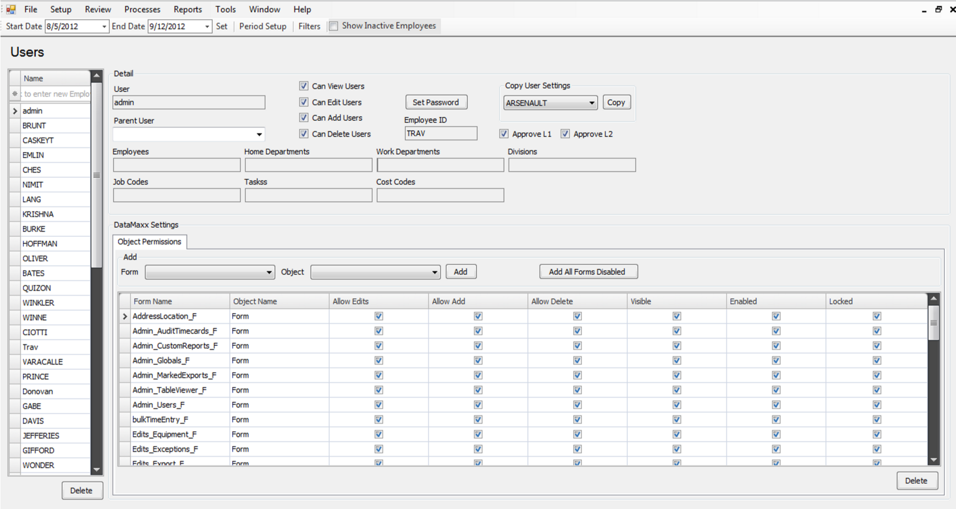

e.

In the Employee ID column add there datamaxx

Employee ID

8.

Each application requires an IP address or URL to the Web Services Software. This can be obtained from your



datamaxx Tech Support representative (support@data-maxx.net) or from your IT department.